* **Output:** Code of test class **AssertionTest.java** with methods using assertions like:

1.assertEquals  
 2.assertTrue  
 3.assertFalse  
 4.assertNull  
 5.assertNotNull

* Code ss:

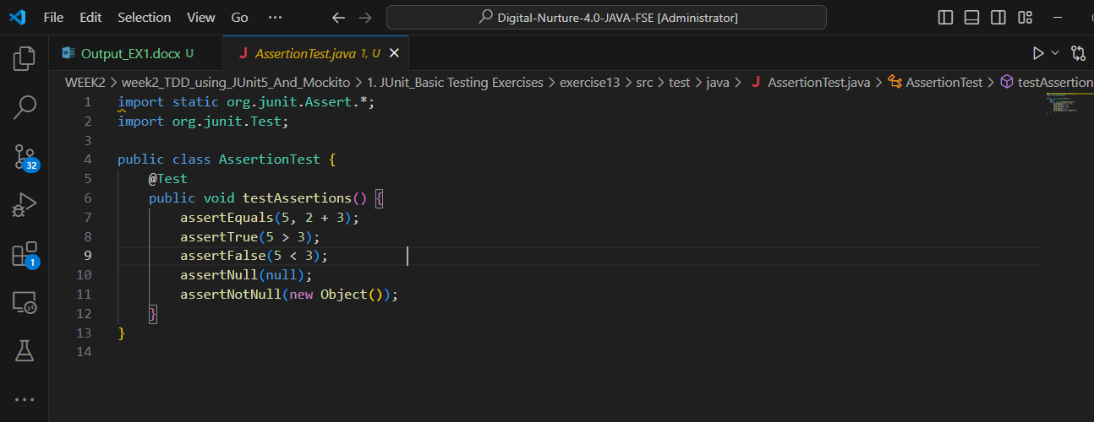

* **Running test cases:**Green or Tests run: 1, Failures: 0 in terminal or VS Code test [view. It](http://view.it) says “**Running AssertionTest**” .

